Charlene Butler
EEE 304
Lab 4

Overview:
From this laboratory experiment, I gained a deeper understanding of amplitude modulation, amplitude demodulation, and the modulation index. Modulation enables the use of smaller antennas in message transmission, making communication systems more portable. It also supports frequency division multiplexing, which allows multiple users to share communication channels by assigning different carrier frequencies separated by guard bands.
Amplitude demodulation can be performed using either coherent or non-coherent techniques. Coherent demodulation relies on regenerating a carrier at the receiver that matches the original carrier’s frequency and phase. In contrast, non-coherent demodulation extracts the message directly from the envelope of the received signal without requiring carrier phase information.
The modulation index, defined as the ratio of the message signal amplitude to the carrier signal amplitude, describes the extent to which the carrier amplitude varies in response to the message signal.

Results:
- 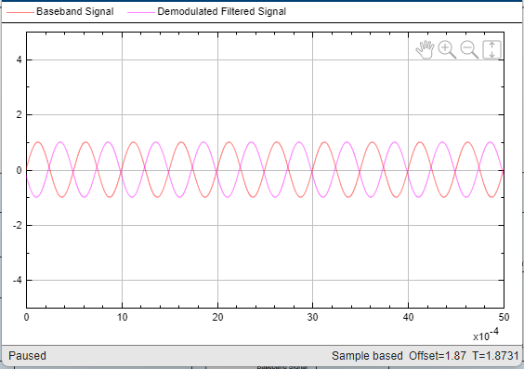
N=10
Cutoff=28000
N=10 gives the perfect demodulation.

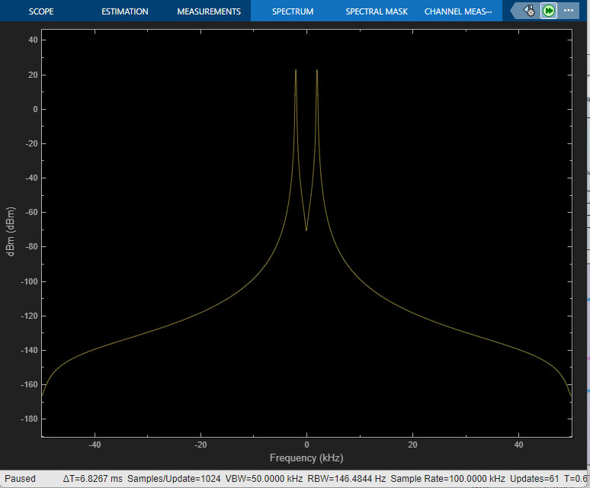
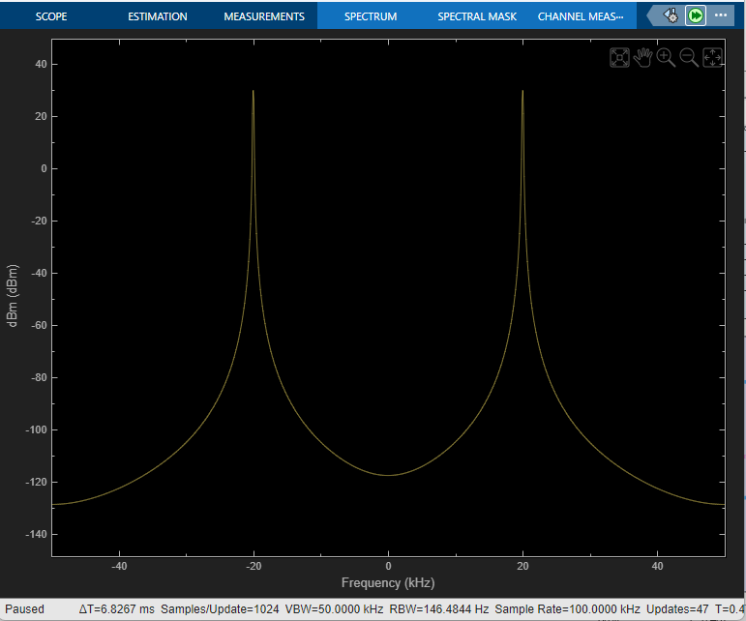
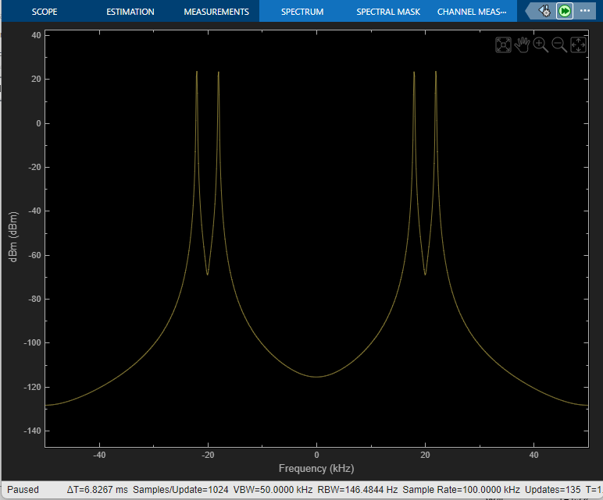
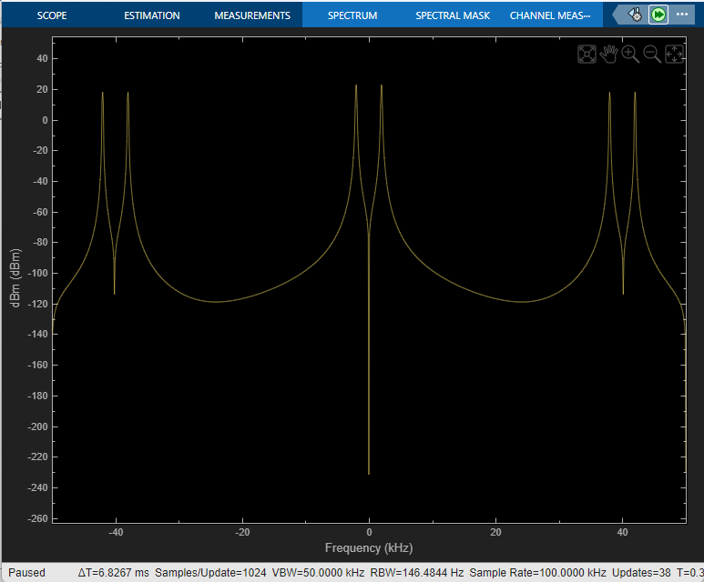
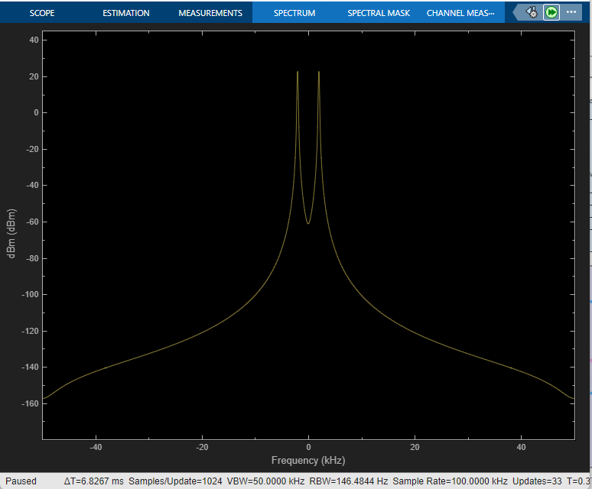
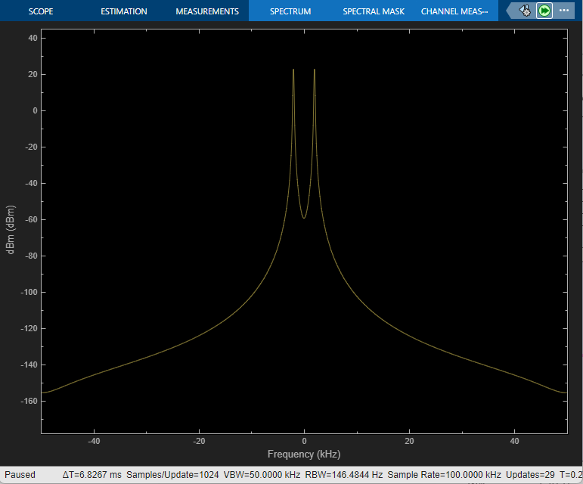
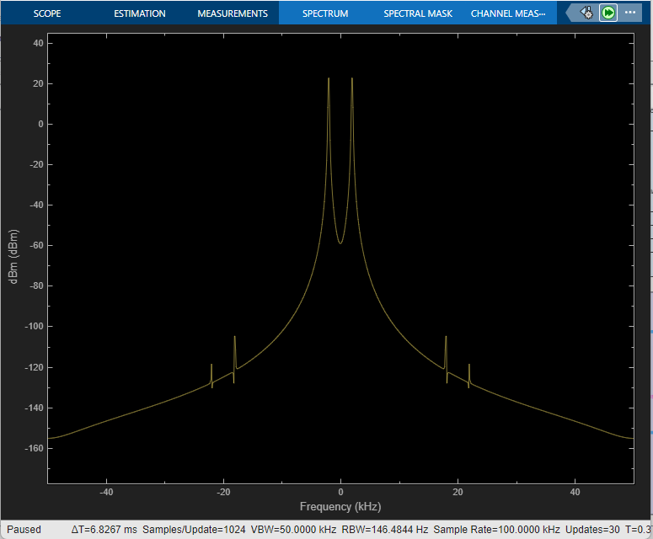
10kHz
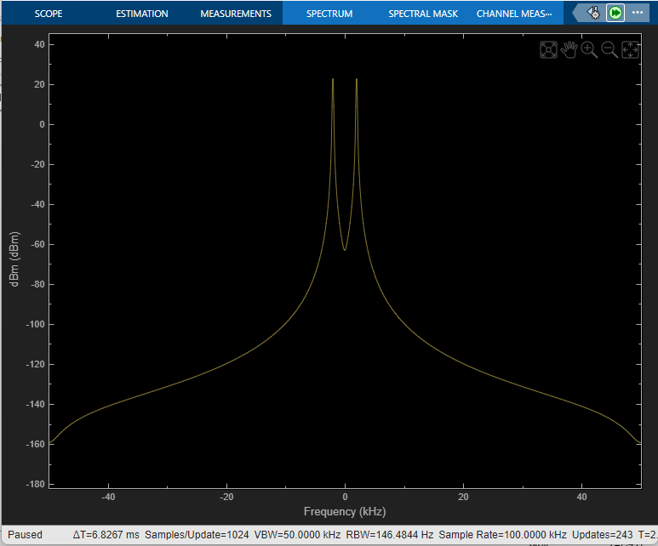
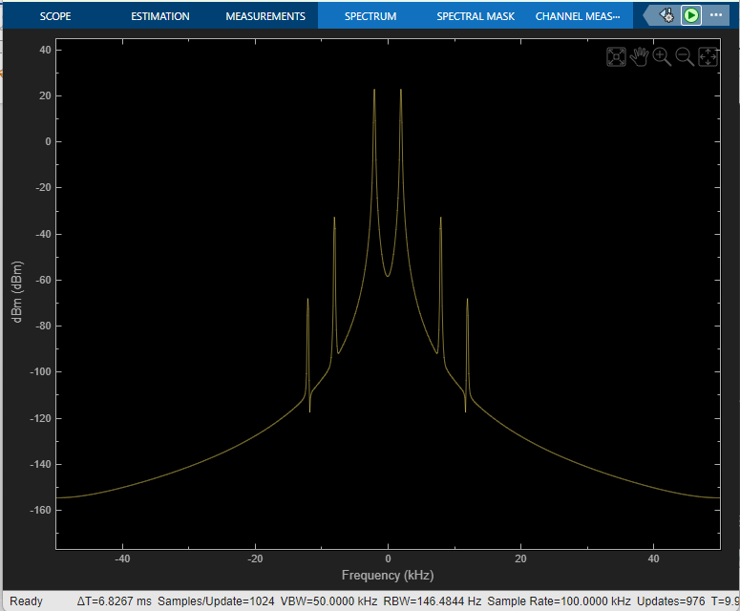
5 kHz
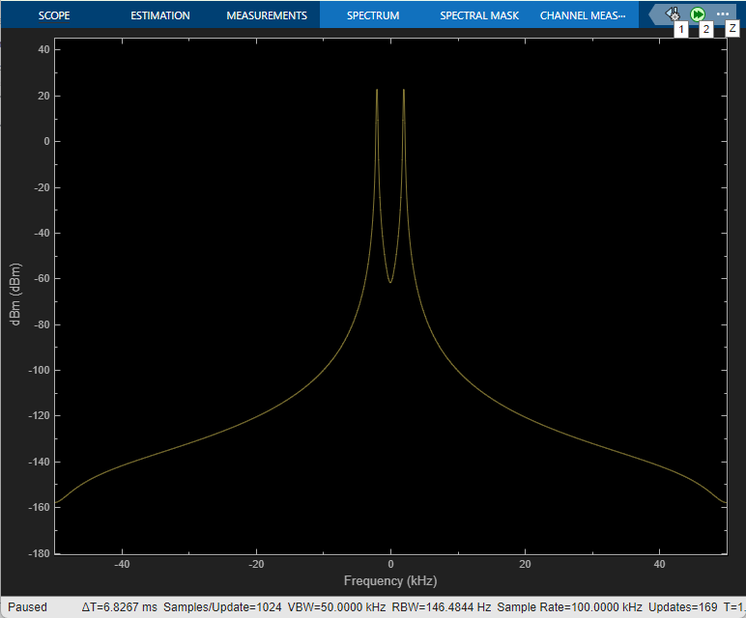
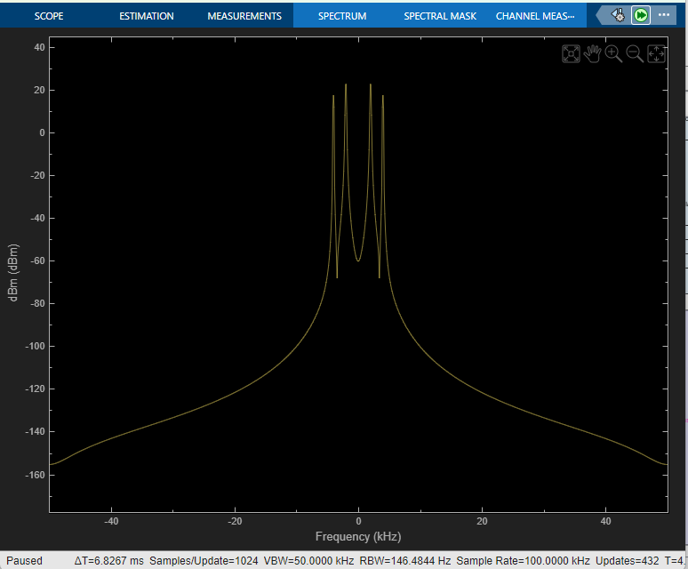
1 kHz
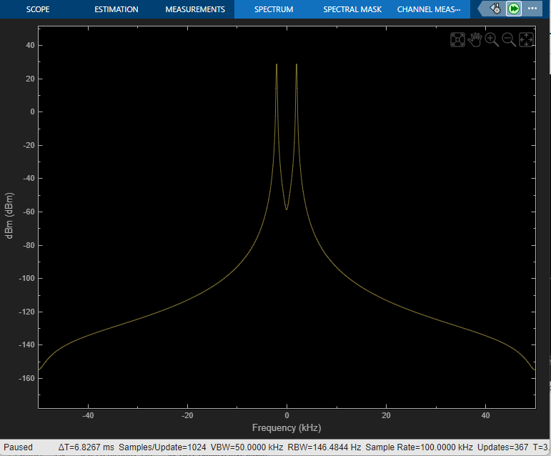
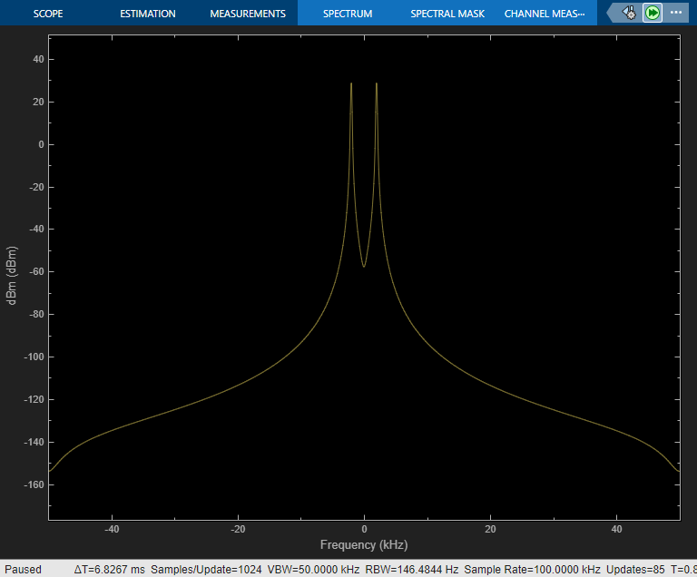
N=2
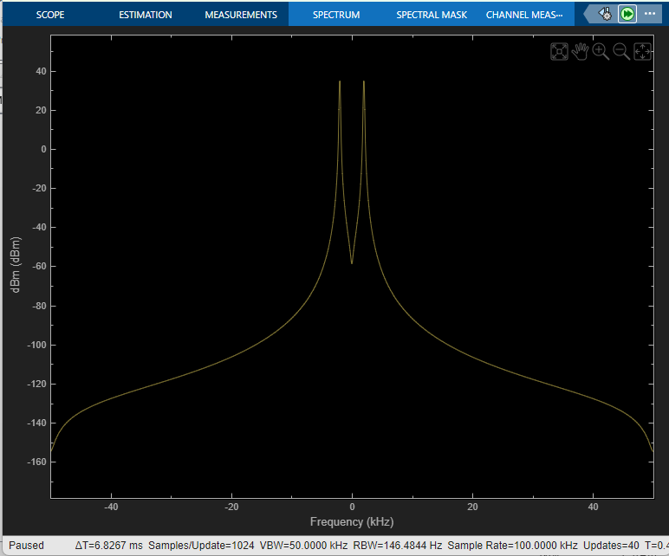
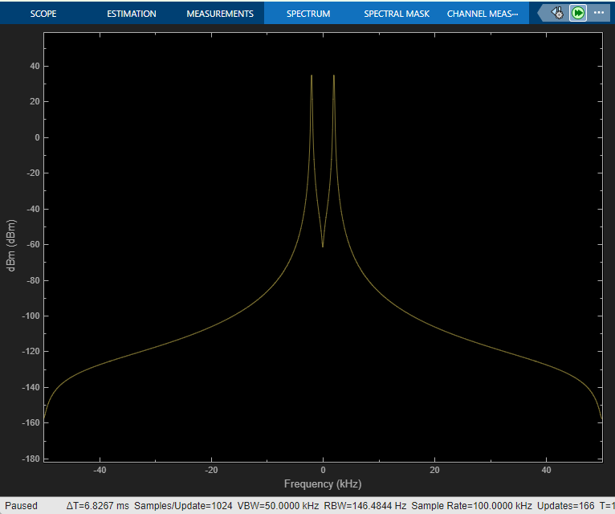
N=4
These do match what was taught earlier.
- 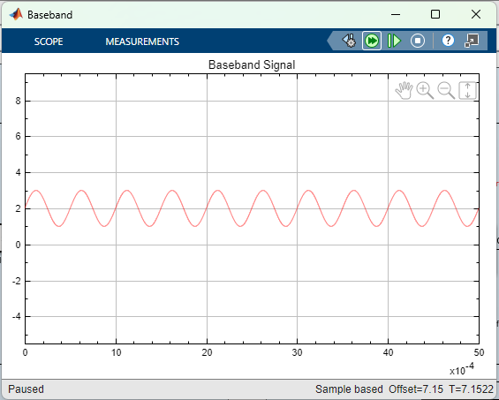
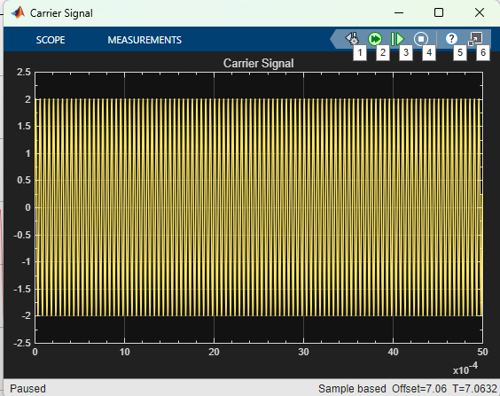

The baseband and the carrier signal are multiplied together.

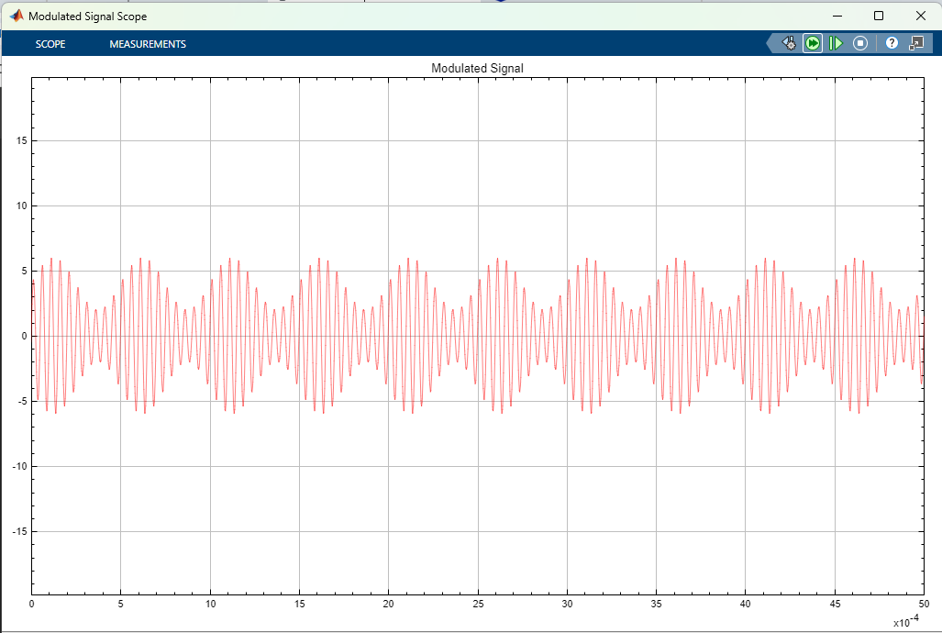

This signal is squared.
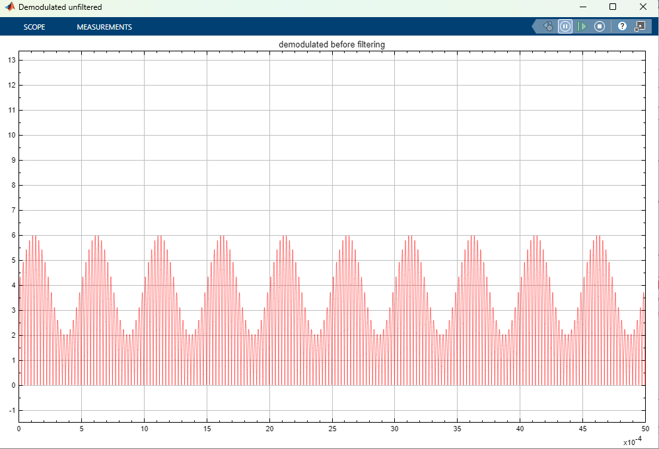

Higher frequencies are removed.
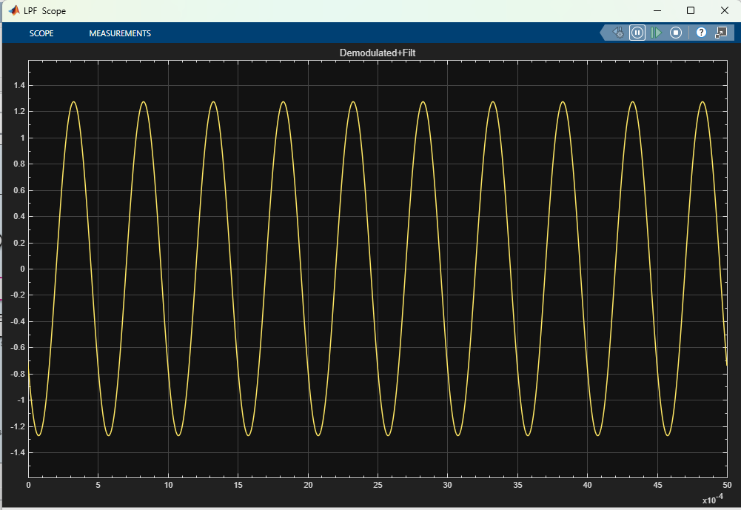

The filter causes a phase shift in the reconstructed. Amplitude is increased as well.
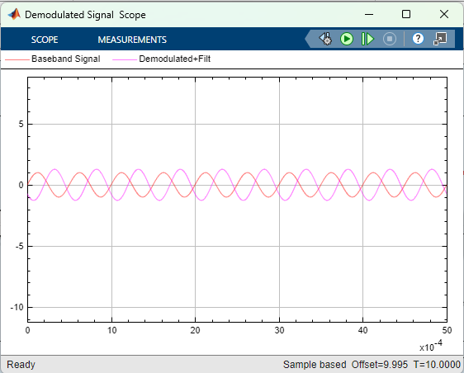
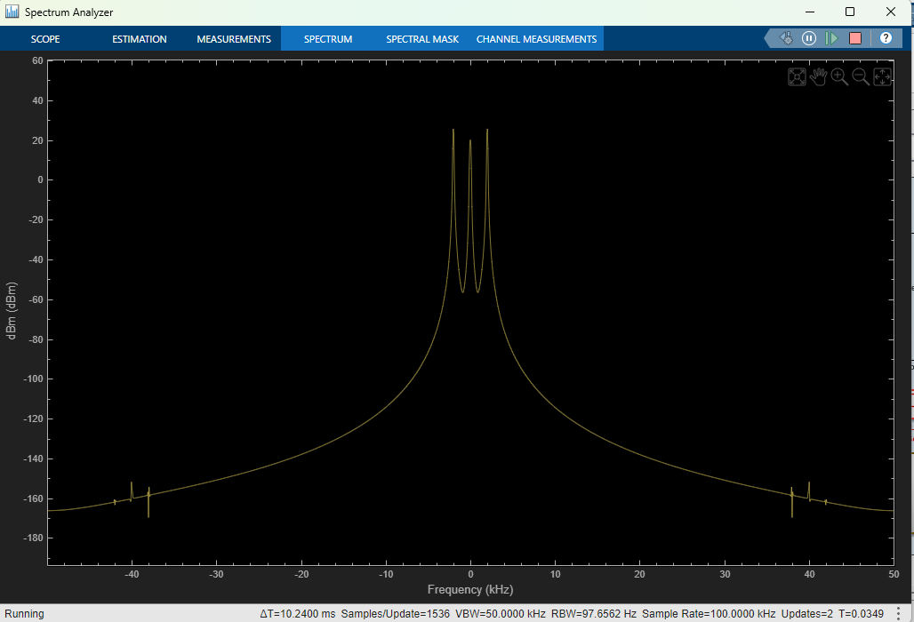
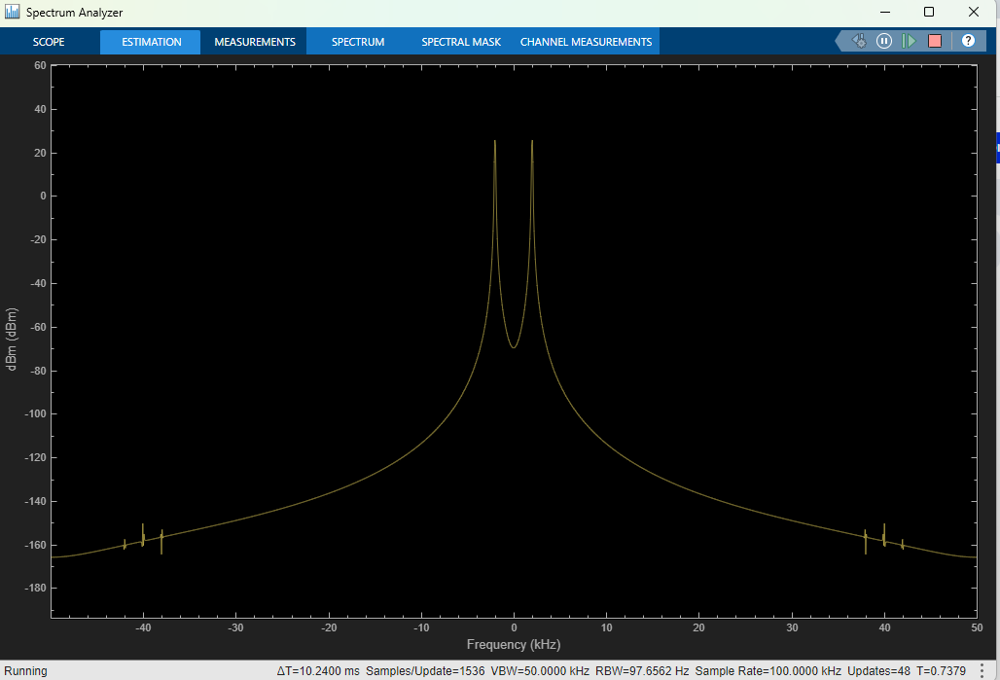

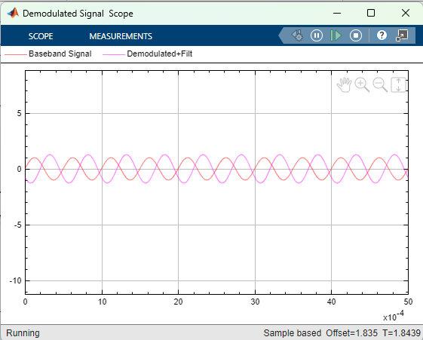
It does not appear that there was any change. I feel like I have done something wrong here and have tried fixing this 6 times. I am unsure what I have done wrong at this point. The frequencies appear to be 6 Hz to 188 Hz.

The modulation index at this point is ½.

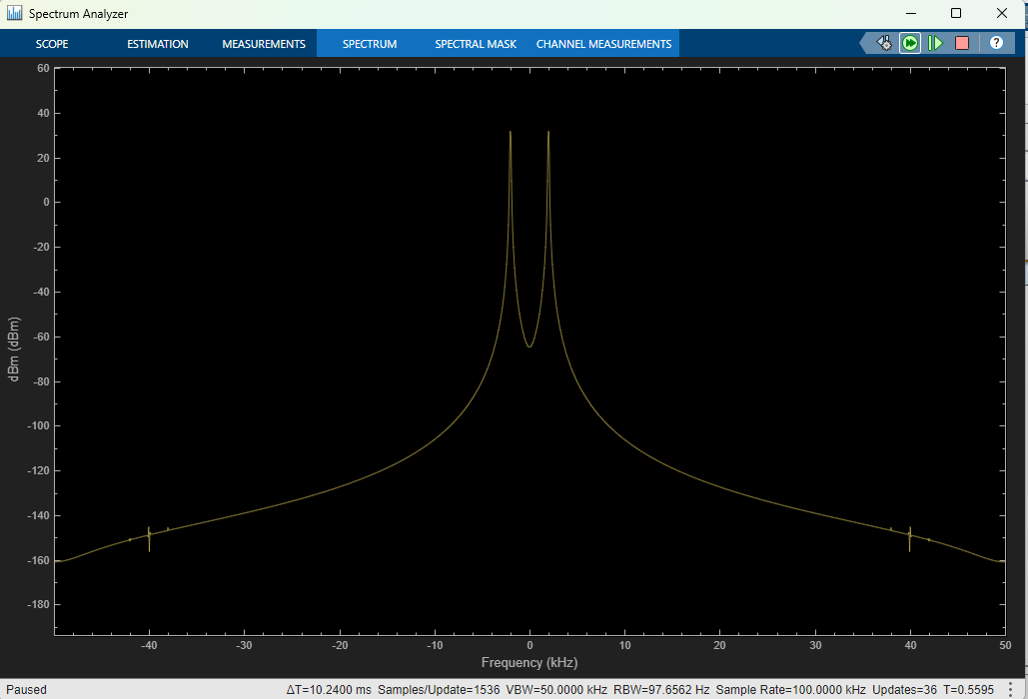
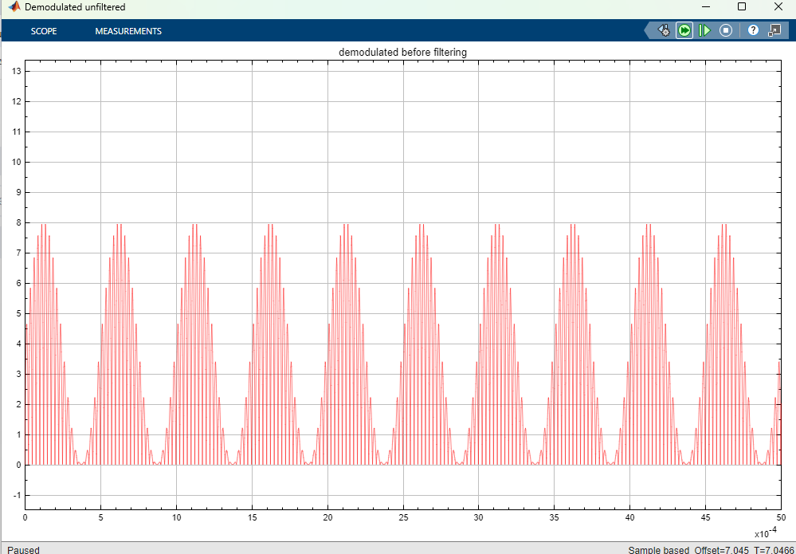
In the signal vs. time plot, the difference was that the envelope increased to 8 and then decreased to 0 for each of its cycles.
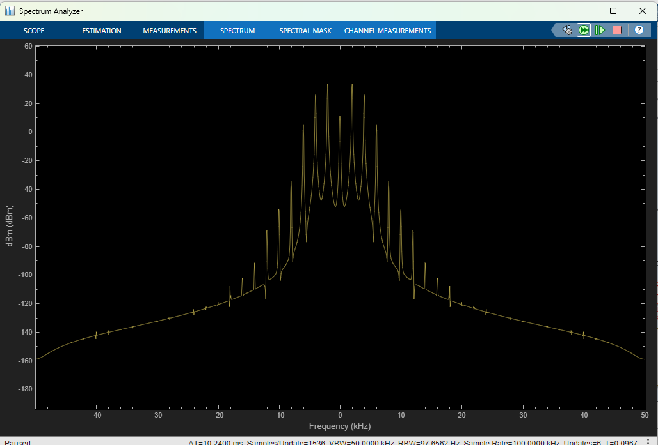
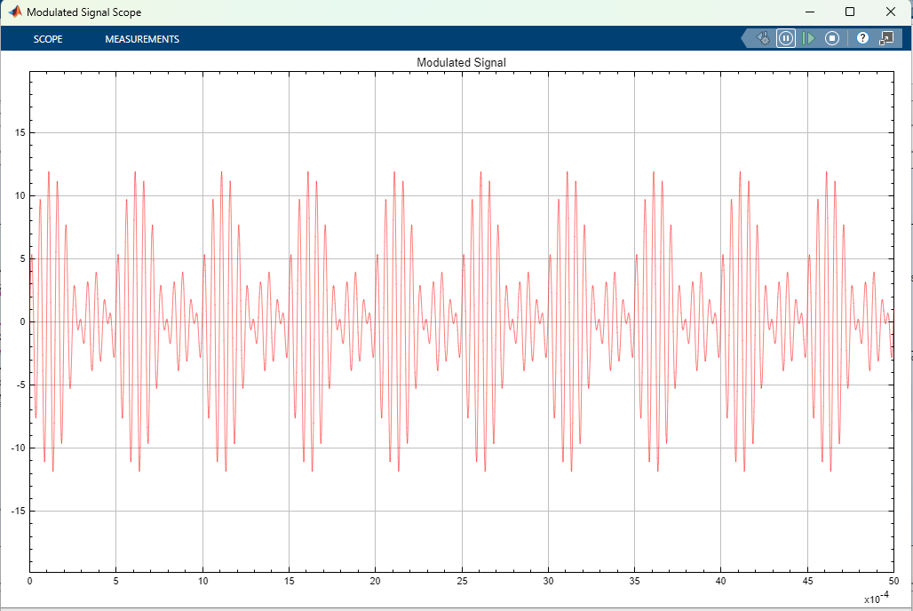
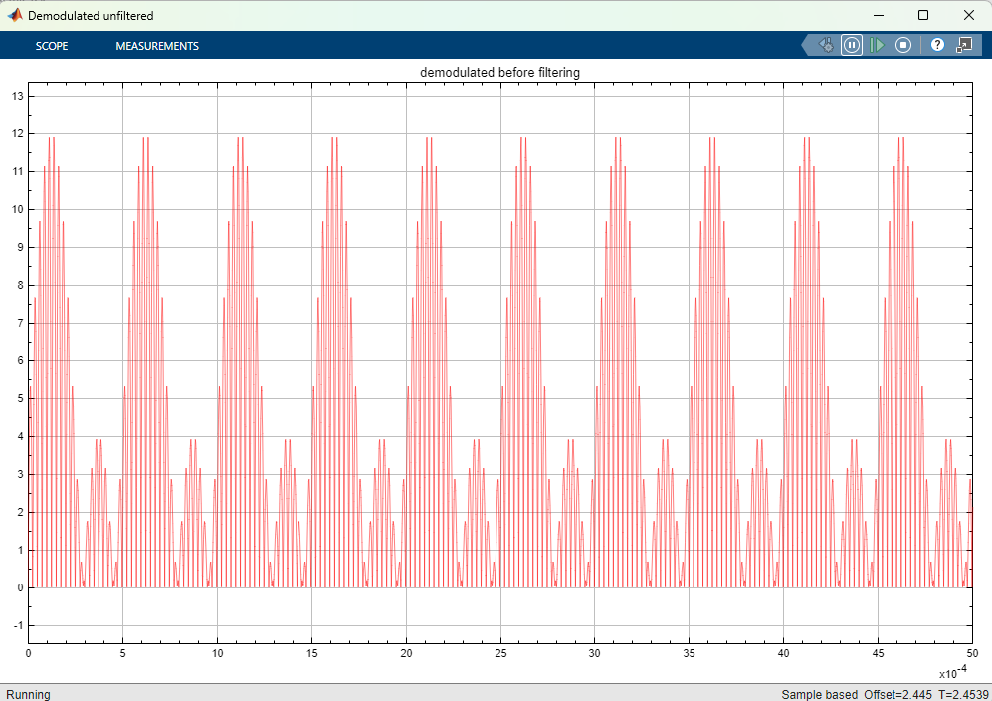
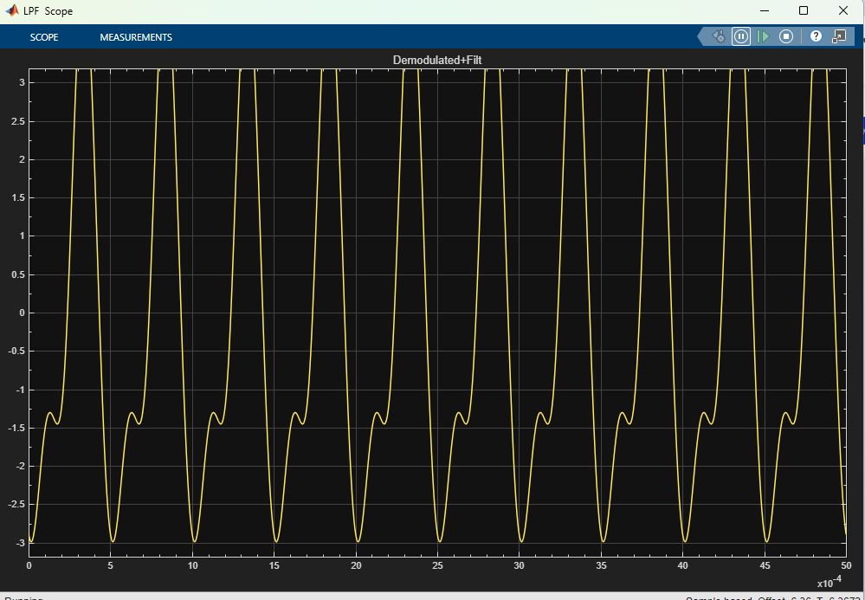
There is an error after filtering the reconstructed signal.
- 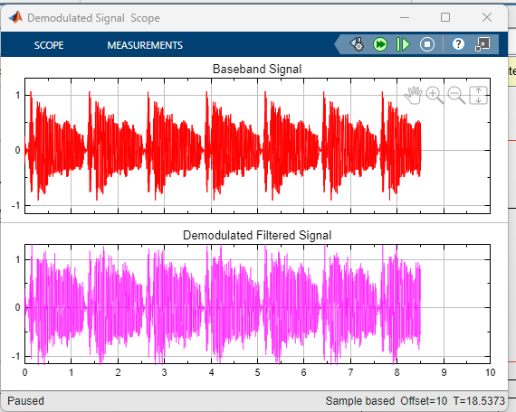
Carrier signal: amp=2, freq=10 kHz. The amp was chosen to be 2 times the baseband signal amp and the freq was chosen to be higher than the baseband.

Analog Filter: Butterworth Lowpass 10th order, 30k rad/s passband edge freq. The 10th order was chosen for its sharp cutoff. The 30k cutoff was chosen to filter out high freq duplicates.

Gain: ½ and was chosen to reduce the modulated signal amp to the baseband amp.

